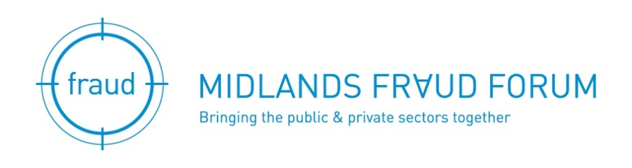

Masterclass
Tuesday 24 March 2020

Cyber, Fraud and Enforcement

Hosted by
KPMG, One Snowhill,
Snow Hill Queensway,
Birmingham, B4 6GH

AGENDA

08.30 | Registration and Refreshments
09.00 | Welcome & introduction
09.05 | Will Davies, KPMG – [Cyber Fraud topic]
09.40 | Mark Thompson, KPMG – Enforcement developments in fraud & corruption
10.20 | Coffee
10.45 | Chris Woods, CyberQ Group – [Cyber Fraud topic]
11.25 | Questions to the speakers
11.30 | Close

SPEAKERS

Will Davies – Cyber Security Consultant, KPMG

Will has worked with multiple large organisations across the telecommunications and financial sectors. His experience has focused on conducting CAS(T) assessments, the government standard to assess telecommunications companies ability to provide and protect secure networks. In addition, Will’s experience included working on a number of technical reviews surrounding vulnerability management and conducting penetration testing to assess cyber security weaknesses that are present within organisations.

Will’s industry experience and breadth of clients has allowed him to gain key insights into how an organisation’s cyber threat landscape can effect their cyber strategy as well as provided an in-depth understanding for threat management and mitigation.

Chris Woods - Director, CyberQ Group

An experienced leader within the cyber security realm, Chris Woods is also the founder and director of CyberQ Group – an award winning cyber security company in the UK. Having previously managed elite security teams at the European Space Agency, HP and Fujitsu, Chris brings over 20 years of pure Cyber Security experience developed within the EU and MENA regions. Whilst at HP, Chris developed and led a cyber security practice, culminating in the acquisition of ArcSight for $1.5b. Chris is now leading a passionate team of cyber and business professionals, developing the next generation of Security Operations Centres using Big Data analytics and Machine Learning. Chris is a committed Information Security Champion and frequent speaker at international conferences and events.

Mark Thompson – Director, KPMG

Mark is a Director at KPMG specialising in forensic investigations and financial crime risk advisory work. Mark has 22 years of experience investigating fraud, corruption, money laundering and misconduct. This includes 14 years at the Serious Fraud Office where he was latterly the Chief Operating Officer, and also the Interim Director for four months in 2018. During this time he worked on many of the UK’s highest profile criminal fraud cases and also headed the Proceeds of Crime Division for four years.
Mark began his career as a police officer with the Metropolitan Police before qualifying as an accountant with the National Audit Office. He then worked for KPMG Forensic for seven years on a range of investigations for clients across the UK and internationally.
Mark’s relevant experience includes:
- Chief Operating Officer of the UK Serious Fraud Office from 2016-2019, and appointed Interim Director by the Attorney General April-August 2018
- Head of Proceeds of Crime Division 2012-2016, leading a team of 40 specialist lawyers and financial investigators working on asset recovery and money laundering aspects of the SFO’s cases.
- Giving evidence to four Parliamentary Committees on behalf of the SFO on confiscation, money laundering and proceeds of crime.
- Major pension fraud case involving £50m that was eventually recovered for the victim pension funds.
- A criminal investigation into false accounting by the directors of a subsidiary of a UK plc which resulted in three guilty pleas.
- A complex high value confiscation investigation to recover the proceeds of crime from a convicted fraudster.
- Investigation of serial insurance fraudster who was eventually convicted of defrauding 23 insurance companies
- The investigation of a UK water company concerning the submission of false information to the regulator.
- A high value multi-jurisdictional civil case involving fraud and money laundering.

REGISTRATION/APPLICATION FORM

The Master Class is free for Midlands Fraud Forum members, or a substitute colleague from their organisation.

Non-members can attend at a cost of £60.00 which includes attendance at any other master class during the next year (excluding the annual conference)

Registration for this event can now be made on the website using the link below:
https://www.midlandsfraudforum.co.uk/event-3773594

For non-members or replacement colleagues please complete the details below and return it to Jo Buckley at info@midlandsfraudforum.co.uk or telephone 07804 694094

I am unable to attend but would like a replacement from my company to attend, please see details below.

Yes, I’d like to attend the Masterclass but I am not a member of Midlands Fraud Forum.

I enclose a cheque for £60 payable to Midlands Fraud Forum.

Please send me an invoice to the address below.

Please complete the details below using capitals throughout.

Members name _______________________________________________________________

Attendee name ______________________________________________________

Job Title ____________________________ Company __________________________

Address _______________________________________________________________

______________________________Postcode__________________________

Telephone Number ______________________Email _____________________________

